

My Career Plan

**Assignment 1**

**(Individual Work - 40 Marks)**

|  |
| --- |
| 1. **My Profile** |
| * 1. My Career Interests (RIASEC)   2. My Career Values   3. My Personality Traits and Skills   4. MySkillsFuture Profile and Skills Passport |
| 1. **My Network (to be graded in Assignment 2)** |
|  |
| 1. **My Career Decision (to be graded in Asssignment 2)** |
|  |
| 1. **My Goals (to be graded in Assignment 2)** |
|  |

**My Career Plan**

Developing a career plan helps you maintain a sense of direction and keeps you focused towards a purposeful goal.

Name: Subbayan Agathiyan

Submission Date/Update: 09/06/2022

|  |
| --- |
| **1.** **My Profile** |
| Understanding yourself is a crucial step in charting out your career plan. PCS1 allows you to identify your career interests, values, skills and personality traits. Knowing how to leverage on your positive qualities and strengths will help you excel in school and at work. |
| **1.1 My Career Interests (RIASEC)** |
| Career Interest |
| **1.2 My Career Values** |
| Career Values |

|  |
| --- |
| **1.3 My Personality Traits and Skills** |
| *(Refer to SDL Prelude to Topic 2.2 – Worksheet 2.2.1 - Identify Your Skills.)*   1. List your top ten Skills: three Adaptive Skills / Personality Traits, five Transferable Skills and two Job-related / Technical Skills.  |  |  |  | | --- | --- | --- | | **Adaptive skills / Personality Traits** | **Transferable Skills** | **Job-related /**  **Technical Skills** | | (1) Humble | (1) Listening | (1) Problem-solving | | (2) Comfident | (2) Analysing | (2) Planning | | (3) Open-minded | (3) Decision-making |  | |  | (4) Negotiating |  | |  | (5) Managing |  |  1. What skills are needed in today’s economy? Please quote at least one article from the Straits Times Online[1]. Which of these skills would you like to develop and why?   ____________________________________________________________________________________________  “In the digital sector, the top three are technology application, data analysis and market research.”  Data Analysis. It is because it would help me in my future job to understand the data trends and also how it could help me evaluate the data too. This would help when doing presentations.   1. Please attach a copy of your Skills Confidence self-assessment results from MySkillsFuture portal. Refer to Annex A for instructions. |
| **1.4 My SkillsFuture Profile and Skills Passport** |
| Please update your MySkillsFuture Profile and Skills Passport – Skills and Certificates (where appropriate). Refer to Annex B for instructions. |

**Annex A - Complete Self-assessments on MySkillsFuture Portal**

(You can refer to the MySkillsFuture Portal Login Guide in Topic 1.1 for Login assistance.)

Login to MySkillsFuture Portal and do the following profiling at the Assessments Section:

1. Career Interests
2. Skills Confidence
3. Work Values

* Click **“Resources”** tab
* Click **“Find out more” in Assessment section**

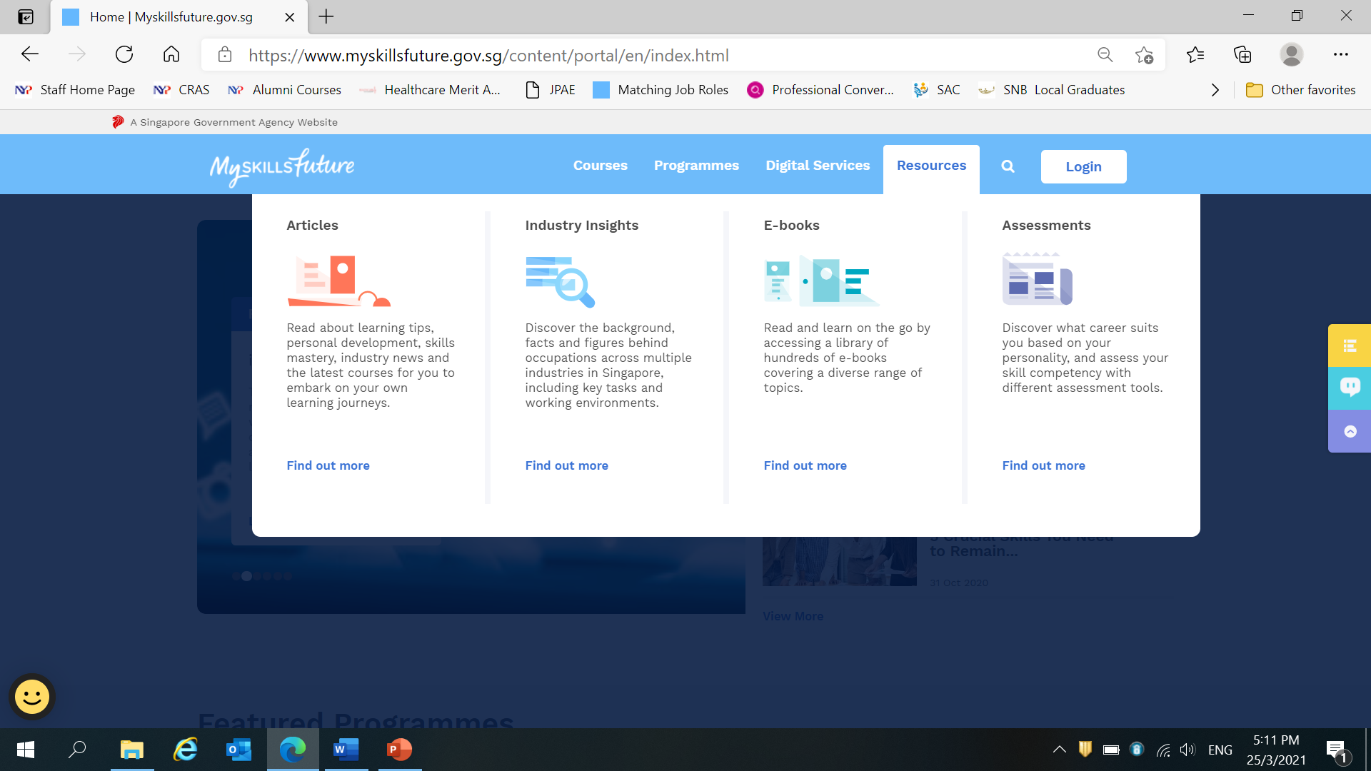



Once you have completed the 3 profiling, please be reminded to attach a copy of the results to your Personal Career Plan. You can refer to the sample copy below.

Career Interest

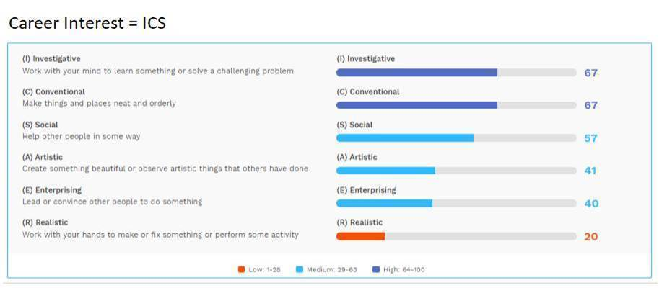

Work Values

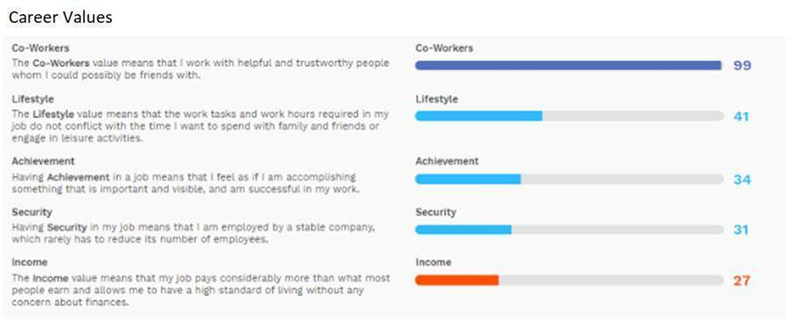

Skills Confidence

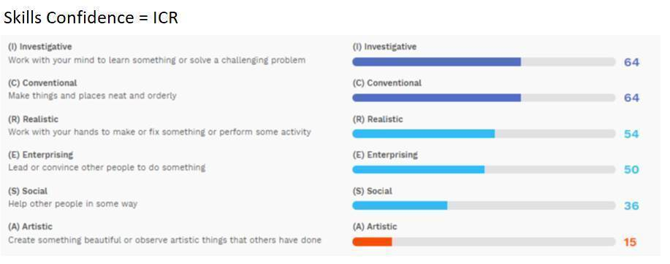

**Annex B - Update Your Profile and Skills Passport on MySkillsFuture Portal**

Login to MySkillsFuture Portal and update the following sections:

1. Profile
2. Skills Passport - Skills
3. Skills Passport - Certificates

Profile

After login, click on “Your ID” and Select “Profile” from the drop-down list.

The Profile page is where you can upload and edit information about yourself pertaining to your career.

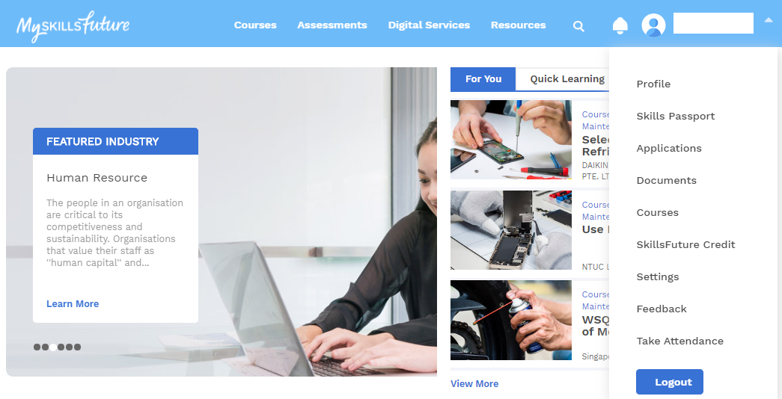

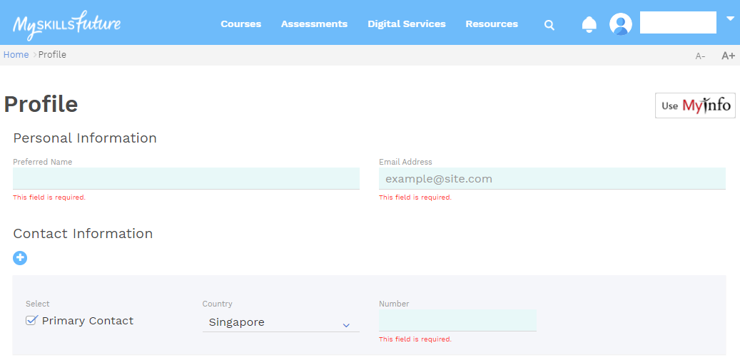

Skills Passport – Skills and Certificates



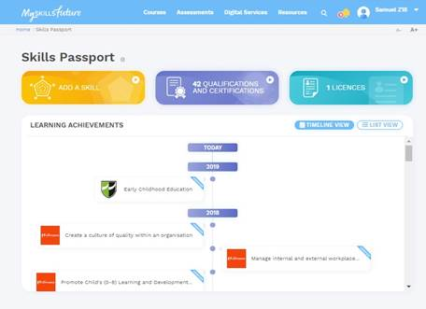

Skills

Qualifications and Certifications

* You can add generic and technical skills. Skills listed are taken from Skills Frameworks. You can add skills outside of Skills Frameworks. You can also indicate the proficiency level of your skills.

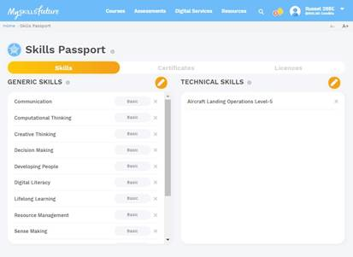

* Certificates can be uploaded by Training Providers, educational institutions or individuals. They can be in PDF as e-Certificates or OpenCert, a new, tamper-proof digital format. Certificates uploaded by Training Providers and educational institutions will appear with a blue ‘Verified’ label at the top right. For now, only Statements of Attainment and WSQ qualifications are available. You will be able to view and download your qualifications or upload new qualifications.

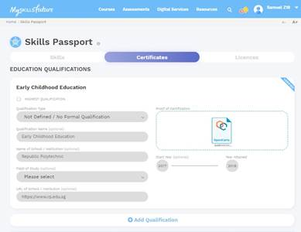

1. All NYP students are given an ST Online account accessible by NYP student email address.